

|  |  |
| --- | --- |
| **The Forgotten Florence “The Dark Path of Lonely King”** | **Simge Haksal – 923606 Okan Doğan – V06436 Mahammad Hasanov – 937414**  **Mode:** Single-Player  **Genre:** Adventure  **Story Type:** Linear Story  **Camera:** Third Person  **Platform:** Windows |

**TABLE OF CONTENT**

[1. Change Log 3](#_Toc533086646)

[1.1. Cover 3](#_Toc533086647)

[1.2. Change Log 3](#_Toc533086648)

[1.3. Software List 4](#_Toc533086649)

[1.4. Asset Editing Software 4](#_Toc533086650)

[1.5. Development Software 4](#_Toc533086651)

[1.6. Organization Software 4](#_Toc533086652)

[1.7. Environments 4](#_Toc533086653)

[1.8. Data Types and Format 4](#_Toc533086654)

[1.9. Data Storage and Access 4](#_Toc533086655)

[1.9.1. Backup 4](#_Toc533086656)

[2. High Concept 5](#_Toc533086657)

[2.1. Periodic Table of Storytelling 5](#_Toc533086658)

[2.1.1. Structure 5](#_Toc533086659)

[2.1.2. Setting, Laws & Plots 5](#_Toc533086660)

[2.1.3. Hereos 6](#_Toc533086661)

[2.1.4. Character Modifiers 6](#_Toc533086662)

[2.1.5. Villains 6](#_Toc533086663)

[2.1.6. Metatropes 6](#_Toc533086664)

[3. Game Settings 7](#_Toc533086665)

[3.1. Locations 7](#_Toc533086666)

[3.2. World Diagram 8](#_Toc533086667)

[3.3. Goal Outline 8](#_Toc533086668)

[4. Themes 9](#_Toc533086669)

[5. Synopsis 9](#_Toc533086670)

[5.1. Premise 9](#_Toc533086671)

[5.2. Act 1- Setup 9](#_Toc533086672)

[5.3. Act 2- Confrontation 9](#_Toc533086673)

[5.4. Act 3- Resolution 10](#_Toc533086674)

[6. Characters 10](#_Toc533086675)

[6.1. Sophie Hatter 10](#_Toc533086676)

[6.1.1. Description 10](#_Toc533086677)

[6.1.2. Backstory 10](#_Toc533086678)

[6.1.3. Circumplex and Relationship Map 11](#_Toc533086679)

[6.2. Calcifer 11](#_Toc533086680)

[6.2.1. Description 11](#_Toc533086681)

[6.2.2. Backstory 11](#_Toc533086682)

[6.2.3. Circumplex and Relationship Map 12](#_Toc533086683)

[12](#_Toc533086684)

[6.3. Howl 12](#_Toc533086685)

[6.3.1. Description 12](#_Toc533086686)

[6.3.2. Backstory 12](#_Toc533086687)

[6.3.3. Circumplex and Relationship Map 13](#_Toc533086688)

[6.4. The King Mario di Marcello 13](#_Toc533086689)

[6.4.1. Description 13](#_Toc533086690)

[6.4.2. Backstory 13](#_Toc533086691)

[6.4.3. Circumplex and Relationship Map 14](#_Toc533086692)

[6.5. Girolamo Riario-The Enemy 14](#_Toc533086693)

[6.5.1. Description 14](#_Toc533086694)

[6.5.2. Backstory 14](#_Toc533086695)

[6.5.3. Circumplex and Relationship Map 15](#_Toc533086696)

[6.6. Zeppy – The Evil Twin 15](#_Toc533086697)

[6.6.1. Description 15](#_Toc533086698)

[6.6.2. Backstory 15](#_Toc533086699)

[6.6.3. Circumplex and Relationship Map 16](#_Toc533086700)

[6.7. The Princess Veronica 16](#_Toc533086701)

[6.7.1. Description 16](#_Toc533086702)

[6.7.2. Backstory 16](#_Toc533086703)

[6.7.3. Circumplex and Relationship Map 17](#_Toc533086704)

[6.8. Interpersonal Circumplex 18](#_Toc533086705)

[6.9. Relationship Table 18](#_Toc533086706)

[7. Story 19](#_Toc533086707)

[7.1. Complete Story of the Level 19](#_Toc533086708)

[7.2. Dialogues on the Level 21](#_Toc533086709)

[8. Detailed Level Description 22](#_Toc533086710)

[8.1. Level Flowchart 22](#_Toc533086711)

[8.2. Documents Level 23](#_Toc533086712)

[8.3. Detailed Area Description 25](#_Toc533086713)

[8.3.1. Howl’s Moving Castle 25](#_Toc533086714)

[8.3.1.1. Inside the Castle 25](#_Toc533086715)

[8.3.1.2. Outside the Castle 25](#_Toc533086716)

[8.3.2. The Hatter 26](#_Toc533086717)

[8.3.3. Palazzo di Nuovo 26](#_Toc533086718)

[8.3.4. Chapel di Amore 26](#_Toc533086719)

[8.3.5. Chiesa Fiorentino 26](#_Toc533086720)

[8.3.6. Galleria di Angelo 26](#_Toc533086721)

[8.4. Measurements 27](#_Toc533086722)

[*8.4.1.* *Measurement for Characters* 27](#_Toc533086723)

[*8.4.2.* *Measurement of the Obstacles* 27](#_Toc533086724)

[*8.4.3.* *Measurement of the Mission Object* 27](#_Toc533086725)

[8.5. Character Statistics 28](#_Toc533086726)

[8.5.1. *Sophie Hatter’s Stat* 29](#_Toc533086727)

[8.5.2. *Calcifer’s Stat* 29](#_Toc533086728)

[8.5.3. *Girolamo – The Enemy* 30](#_Toc533086729)

[8.5.4. *Zeppy* 30](#_Toc533086730)

[9. Data Management 31](#_Toc533086731)

[9.1. Paths and Project Structure 31](#_Toc533086732)

[9.2. Naming Convention 32](#_Toc533086733)

[10. Reference Lists 33](#_Toc533086734)

# Change Log

|  |
| --- |
| logo_bt_800x200 |

**THE FORGOTTEN FLORENCE**

-The Dark Path of Lonely King-

|  |  |
| --- | --- |
| Purpose | This is a briefing document for following the process. |
| Creation date | 24.10.2018 |
| Current owner | Simge/ Mahammad / Okan |
| Last modification | 07.01.2019 |

**Table 7.** *Description*

|  |  |  |
| --- | --- | --- |
| Revision History | | |
| Who | **When** | **What** |
| Simge | 24.10.2018 | Created this document |
| Simge | 29.10.2018 | Wrote the basic subjects of the project |
| Simge, Okan, Berkdeniz | 04.11.2018 | Setted High concept and Game Settings |
| Simge | 05.11.2018 | Added World Diagram |
| Okan | 06.11.2018 | Added some concept |
| Berkdeniz | 06.11.2018 | Added and organized the concept |
| Okan | 07.11.2018 | Done the character subjects |
| Berkdeniz | 07.11.2018 | Done the character subjects |
| Simge | 07.11.2018 | Added map relations |
| Berkdeniz, Okan | 08.11.2018 | Made the circumplex of the characters |
| Simge | 08.11.2018 | Re-organized the circumplex of the characters then added it |
| Okan, Berkdeniz, Simge | 08.11.2018 | Founded a Title |
| Okan | 08.11.2018 | Editted Data Organization Template |
| Berkdeniz, Simge, Okan | 08.11.2018 | Looked over the project and re-organized some parts |
| Simge, Mahammad, Okan | 21.11.2018 | Checked all the mistakes of the first submission |
| Simge, Mahammad, Okan, Berkdeniz | 22.11.2018 | Looked for other projects of this year |
| Simge | 23.11.2018 | Corrected all the mistakes of the first submission |
| Mahammad | 24.11.2018 | Wrote complete story and diologues |
| Simge | 25.11.2018 | Drew relationship map and fix their circumplexes |
| Okan, Berkdeniz | 26.11.2018 | Modified the data management file |
| Simge, Mahammad, Okan | 27.11.2018 | Looked over the Project before the second submission |
| Simge, Okan | 06.12.2018 | Got feedback from professors and corrected mistakes |
| Simge | 07.12.2018 | Designed logo and reorganized relationship maps |
| Simge | 08.12.2018 | Designed a new world diagram and specified locations |
| Simge | 09.12.2018 | Redesigned flowchart |
| Simge | 10.12.2018 | Drawed detailed designs |
| Simge | 11.12.2018 | Wrote detailed area and level description |
| Simge | 20.12.2018 | Got feedback and redid “Data Management” document |
| Simge |  |  |
| Simge |  |  |
| Simge |  |  |
| Simge |  |  |

**Table 1.** *Revision History*

## Software List

Unity 3D 2017 30f3, MacOS Mojave, Windows 10, Windows 7, Microsoft Office, Ghost 2.0

## Asset Editing Software

Draw.io, Adobe Photoshop

## Development Software

Unity, UE, NWN Toolset, GIT, SVN, Sublime

## Organization Software

Microsoft Office

## Environments

OSX, Windows

## Data Types and Format

This is very dependent from the previous section. Based on the tool you use there are preferred format. It is also true the opposite: can start from here to decide the software list.

You should have one subsection for every category of data you need to manage.

## Data Storage and Access

GitHub for Backup Google Drive: Okan, Simge, Mahammad

### Backup

Google Drive: Mahammad, Okan, Simge

# High Concept

“The Forgotten Florence” is a third person, single player, adventure, role playing game. It tells about the new adventure of Sophie and Calcifer, but this time Howl does not exist until the end of the story because he has disappeared. During this period, Sophie has realized to be a powerful witch, but she is still inexperienced and needs the training to master her skills. Suddenly, a new colored sector has appeared on the magic door because of Calcifer's treacherous and unaccounted sibling, Zeppy. Then the thing inside the door forces them (pulls them) inside to it. Because of that Sophie and Calcifer go in a thing like a blackhole.

Sophie and Calcifer find themselves in a land which is called The Forgotten Florence. They will face some difficulties like enemies and obstacles to know that where Howl is. Although they have a lot of challenges, they think they can find Howl’s place by using their intelligence and magical powers.  In this way, you can complete the mission successfully which the King of The Forgotten Florence, Mario di Magnifico, will give you. Moreover, you need to be careful about the dangers will come across your way especially the ones that Girolamo, the major enemy of the King, will bring who is the head of the king’s knights but a dark person. Secretly he supports and admires dark magic.

## Periodic Table of Storytelling

### Structure

**https://lh4.googleusercontent.com/URC7q6twHB0y8WXrFR4hGBT41a4X7oAoUYc1x-F_myOnIg6y6VF6283h4S6ArK79uFOytqXIGa2MyAjmHk0q7gbJ-XZ7Y-uPaOHq1YQ9CwrNQWu-a_FL4AeNmqWTYfef4Q6fznXO3as:** The Three Act Structure is a typical and frequently-used narrative structuring template. There are 3 acts which consist of setup, confrontation, and resolution. In the first act, the main characters are introduced, Sophie and Calcifer. In the second act, Sophie and Calcifer try to complete the mission that the King gave them. During this longest journey, they will encounter [obstacles](https://tvtropes.org/pmwiki/pmwiki.php/Main/ThresholdGuardians) in the form of the enemy (Girolamo) and objects/obstacles. In the last part, the story wraps up since it is falling action part. At some point during this stage, Sophie will be close to accomplishing the ultimate goal, but [events will conspire to prevent success](https://tvtropes.org/pmwiki/pmwiki.php/Main/YouCantThwartStageOne). However, this is the resolution part, so she completes the mission eventually **[1]**.

### Setting, Laws & Plots

**Rq:** In “Redemption Quest”, whatever the case may be, the character is in a bad place but wants to do better, and they are granted one final chance to do so, usually in the form of a grand, nearly impossible task **[1]**.

### Hereos

https://lh4.googleusercontent.com/sQrOe3EIsiLGJLwpKvXeeCO0eZIWFoeMSWMtS_uHK_WVVd5t15oJZUjkcIgBF62rNcQaYFQOv-Ji2gTf_oK6tGKCWcA4K_BUYJ-mT_oG-E_YW_fmw2ByCrVYxvGwZzVK6GnQ39NS**Det:** The “Determinator” is a character who never gives up. This character can be either good/evil. Also, s/he can be old or young. It is not important. Nobody can stop the Determinator. In our level design, this character is Girolamo. He fights with Sophie and Calcifer, and he defeats. But, he does not give up and continues to follow them. He has one goal; finding the “crown” and prevent the main characters do not reach it before him **[1]**.

https://lh3.googleusercontent.com/HM-2U-XE5iCTfMSvJMJsttk49mVqdCIlrbLZio03gu-drGdosPTzcxDf0p6zRDVZm_D-FMH69zK6Aw9MwwN4I0k1A5wBuZv7AuHnLQZojMX02h6vu7b6ng0z8eNbx0Cs73jN2Aw4**Pg:** The “Plucky Girl” should be a young woman who is brave and optimistic like Sophie. The character looks like the Pollyanna. She is sweet and wise. Also, she has a strong sense of optimism and an unassailable spirit **[1]**.

### Character Modifiers

 **P:** The “Protagonist” is the principal character of a story. S/he is usually the hero, but not always. Behind all other characteristics, s/he can be Villain Protagonist, The Hero, or an Innocent Bystander. Moreover, you can generally tell who the protagonist is because the story is about them. The Antagonist is equally significant since they oppose the actions of the protagonist **[1].**

nesne içeren bir resim

Yüksek güvenilirlikle oluşturulmuş açıklama **A:** The “Antagonist” is in the opposite position from The Protagonist. Because of this, antagonist exists for the opposite target for the efforts of the Protagonist. They only must oppose the Protagonist. For example; if the Protagonist is evil then the Antagonist is the one holding between them and their aims. S/he usually provides the opposition during the story **[1].**

### Villains

https://lh3.googleusercontent.com/cOqy0wBeo77s8e2oe0dDIjuj6LWRf3_SDTEE0rtlMYygZWO5jlFqMgnwrQuEV5r1tnfhcTu2ZAcCR2-hqDqrb4N7Il3ufgIn4Fp3e4haaxVt9XueT7ZlZnwxtB_gZVV2yZGisJ4p**Etw:** We took a popular character and introduce us to the evil version of this character. Typically, the evil twin will be identified by the same actor as the regular character. In most of cases the twin is evil; only seldom does an evil character suddenly find themselves contending with a good twin, and in those cases, the good version is often simple-minded or purely comic. This explanation matches up to our new adventure with the characters Calcifer and Zeppy **[1]**.

### Metatropes

https://lh3.googleusercontent.com/c4IIMrcT-jYen8pShGhjiZFmX53oE_MThP9Kj7NLYmyFlLEdNDPzch0DDZHG4wIWyG3fxomlqKvBECUKvaT192ea5ZtW3Fr7xyRK-_pcU49Fk6FMfjlSwhCX6nS9So5IuDFBYK-l**Rod:** The “Rule of Drama” means that things are going to be much more drawn out, messy, unpredictable, and complicated. Also, in fiction, even the ones known for their intelligence tend to make stupid mistakes just to get them messed in an adventure since there is no drama in being too smart or prepared to either avoid or prevent most shameful situations. Fundamentally, the journey is widely considered more important than the destination, so everything cannot run too smoothly **[1]**.

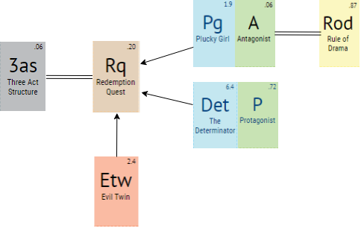

**Figure 1.** *Periodic Table of Storytelling*

# Game Settings

In this game, there is an enemy, a demon, a princess, and a king apart from Sophie, Calcifer and Howl. The story is set in the magical land called The Forgotten Florence, similar a land of Italy, a place where is significant in the Renaissance, Florence. Mario di Magnifico is in love with Florence that’s why he created this land that full of magical power. Thus, technology has not developed yet, you will use primitive things. Some places in the Forgotten Florence, and of course Howl’s Moving Castle are the places where the characters most often are.

The relationship between the Forgotten Florence and the Moving Castle is Howl. Howl is kidnapped by an Italian magician so that the new color appeared on the sector with the act of Zeppy. In this way, the door is opened to Florence. You will visit different places in Forgotten Florence according to the order in the word diagram because you must rescue the King’s daughter life, Veronica, to find Howl himself.

## Locations

**Howl’s Moving Castle:** The Castle that Calcifer moves it by using his power. He lives here with Howl and Sophie.

**The Hatter:** A hatter where Sophie and Calcifer entered to ask questions about the magical land.

**Palazzo di Nuovo:** Marcello family lives here.

**Chapel di Amore:** This palace has been the symbol of the love of Forgotten Florence where Mario di Marcello fell in love with his wife.

**Chiesa Fiorentino:** The enemy and obstacles appear in front of this church. It is surrounded by touristic palaces.

**Galleria di Angelo:** A unique location in the world that alternates perfectly restored historic art and the lost crown is hidden there.

## World Diagram

metin, harita içeren bir resim

Çok yüksek güvenilirlikle oluşturulmuş açıklama

**Figure 2.** *World Diagram of the Project*

## Goal Outline

1. Find Howl
   1. The new colored sector has appeared on the magic door.
      1. Try to understand where you are.
         1. Discover the new city to find Howl.
      2. Reach the hatter.
         1. Ask questions about the city and people.
            1. Hatter gossiped, and the King knew the new guests.
      3. Go to the palace of King Mario.
         1. Understand the situation of the King and themselves.
         2. Make negotiation with the King and accept the mission.
   2. Rescue the Princess life to know where Howl is.
      1. Begin the journey from Chapel di Amore.
      2. Fight with Girolamo in Chiesa Fiorentino.
      3. Go to Galleria di Angelo to look for the magical crown.
         1. Fight with evil spirits
         2. Take the help of evil twin Zeppy.
      4. Take the crown and go to Palazzo di Nuovo.
      5. Give the crown to the King.
      6. Get the letter which has information about the Howl’s place.
   3. Go to the place where Howl stays like a captive.

# Themes

The main theme of this story is **“Family & Love”**. In this adventure, all the evil is destined to be destroyed because of the love of friends. The king is trying to help his daughter which refers to family, and Sophie is trying to find her love Howl with her reliable friend and her companion Calcifer.

The second theme is **“Courage and Heroism”**. The story goes around so that Sophie will defeat all enemies and be able to save Howl which exactly defines her character of being the plucky girl.

The other theme is **“Hope & Trust”**. When Sophie felt herself like hopeless, Calcifer encouraged her with lovely words. He supplies hope for her since they have a strong relationship in that story. Also, the only chance to find her beloved is trusting to the King Mario. Otherwise, she cannot able to find Howl herself.

The last theme is **“Magic”**. Magic is seen to be pursued as a career choice rather than something that comes from within, but there are also those in whom the gift lies unbeknownst to them, and Sophie is one of these people.

# Synopsis

## Premise

Sophie is a brave and determined woman and witch. She is cursed by the witch of the Waste and left home and set off through the countryside. She started to live Howl’s Moving Castle with Howl, and Calcifer luck into something for a long time. She was in love with Howl, a powerful wizard, before she cursed. The Moving Castle is with a magic door that allows to reach other places in the world, also in the past. By the way, she learned that Howl's life is somehow bound to Calcifer's and that Howl has been transforming into a bird-like creature to interfere. After the big war between the fictional kingdoms, Howl and Sophie turned into their own appears. In the end, all of them traveled high in the air in a new flying castle **[2]**.

## Act 1- Setup

After Howl disappeared mysteriously, Sophie has realized to be a powerful witch, but she is still inexperienced and needs the training to master her skills. At that moment, Sophie and Calcifer who are great friends was sitting in Moving Castle. Suddenly, a new colored sector has appeared on the magic door because of Calcifer's treacherous and unaccounted sibling, Zeppy. The new color is in a magical place called “The Forgotten Florence”.

## Act 2- Confrontation

When Sophie and Calcifer started walking in the streets to understand the place and its people. They saw a hatter and asked some questions about the city. The hatter gossipped on them and the King knew that there are new guests in Forgotten Florence, and one of them is a witch, and the other is a demon. He evocated them into the palace and give them a mission to rescue her daughter’s life. In return, King promised to find Howl. The mission is finding the crown. In this way, Princess Veronica's spirit would be saved from evil forces. This is the only way to rescue Howl, the King can find him since he is a powerful and authoritative man. Also, the King’s master enemy Girolamo trying to prevent them.

## Act 3- Resolution

Sophie and Calcifer started to look at the crown. Along the way, they ran across not only obstacles like barriers but also Girolamo, the enemy of the King. Sophie was desperate and missed Howl so much but found the crown with the help of Calcifer’s twin in Galleria di Angelo. Zeppy was cruel. However, when he saw his twin unhappy, he found themselves contending with a good twin, and help him and his friend Sophie. Finally, they gave the crown to the King, and Mario di Magnifico gave the location of Howl in an envelope, the letter. They save both the princess and Howl. Sophie found his lover with hard effort.

# Characters

## Sophie Hatter

### Description

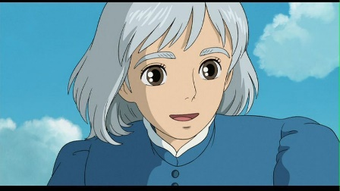The story is centered on Sophie Hatter. She is a young woman who is eighteen years old. She was living in the land of Ingary. She has brown eyes and brown long hair. Before she met a wizard, Howl, she was shy and unconfident. With the curse of Witch of the Waste, she looked like an old woman with her gray short hair. However, one thing did not change which is herself. She is still an optimist, charitable and friendly with the help of her good heart. Now, she is living with her best friend Calcifer in a moving castle with her disappeared love, Howl **[3]**.

### Backstory

Sophie was the eldest daughter of her family, and she lives a boring life by working as a hatter in a small magical kingdom of Ingary wiyh her father and her step-mother. She was working in her late father's hat shop, when her father died. Due to Howl who is the man that Sophie fell in love, she is cursed by the Witch of the Waste. Sophie leaves her friends, her step-mother, her hometown and the hat shop in order to find a cure without anyone seeing and recognising her. Then, Sophie became not only an old woman but also a brave and adventurous woman. Because of her new appearance, she left her home and the hat store. She found moving castle with the help of something spiritual. While she was living with Howl and Calcifer, she fell in love with Howl, and the curse started to break with this powerful love **[3]**.

### Circumplex and Relationship Map

**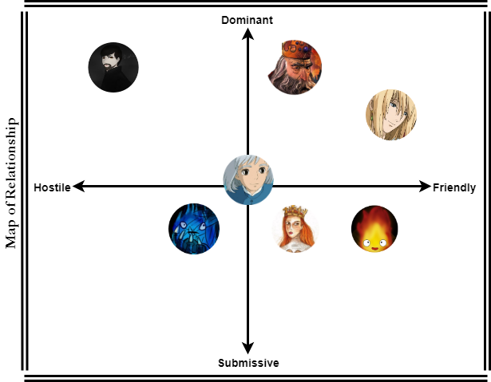**

**Figure 3.** *Circumplex of Sophie Hatter* **Figure 4.** *Relationship Map of Sophie Hatter*

## Calcifer

### Description

iç mekan, bakarken içeren bir resim

Yüksek güvenilirlikle oluşturulmuş açıklama

Calcifer is the fire demon that helps Howl to move his famous castle and with other errands in the castle during the movie and in the novel. It is the mix of red, orange and yellow. He has tiny licks of flame that serve as arms. After Sophie moved into the castle they became friends and ran to adventures together, saved Howl’s life, since Calcifer is a good demon. He eats wooden logs as a meal. Since he looks like a fire, he afraid of the water. Besides he is a very powerful creature himself, with a great deal of magical ability. Moreover, he can move around by floating in the air. As he is a demon, he cannot be trustable. His humor is different than the other characters such as he can keep information from others even if it is a useful information. Despite everything, Calcifer still continues to help Howl and Sophie **[4]**.

### Backstory

He has been with Howl at the Moving Castle since their deal. Calcifer was a star, and he fell in Howl’s hand before he could fall to earth and disappear it. At that moment Howl and Calcifer made a magical contract. According to that, the fire demon agreed to help Howl to heat him and move the Howl’s Castle. Calcifer lived for many years in Howl’s moving castle. One day, a new person came the home who is Sophie. They became extremely close, especially after Howl left them. He promised to Howl to use his magic to break the curse on Sophie. He has chosen to stay with Howl even though the contract has been broken **[4]**.

### Circumplex and Relationship Map

### 

**Figure 5.** *Circumplex of Calcifer* **Figure 6.** *Relationship Map of Calcifer*

## Howl

### Description

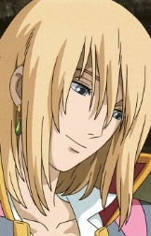

Howl is a wizard. His appearance in the movie is changing continuously. Howl has shoulder-length straight light blonde hair. He has light blue eyes. He is tall and slim. He gave a lot of importance to his appearance. We can understand this when Sophie cleaned his bathroom and mixed some hair potions. Howl is also a very kind wizard. He made good magic. Moreover, he is good-hearted and charitable with Calcifer and Sophie. For example, he allows them to live with him in his moving castle, always trying to protect them from any danger since he loves them very much and is very forgiving of their mistakes **[5]**.

### Backstory

He gifted with a natural talent for magic, he began studying it and became a clever wizard. One night, Howl caught a falling star called Calcifer and made a contract with him. He gave his heart to the creature, binding them together, and allowing Calcifer to live his castle. During this time, Howl courted and then dumped the Witch of the Waste, who put a curse on him. Howl infrequently did work for the King's army but avoided meeting with them as much as possible. Then, he met with Sophie when he rescued her from soldiers. Because of this incident, Sophie cursed and with the help of something spiritual, Sophie started to live with Howl and Calcifer until Howl disappeared **[5]** …

### Circumplex and Relationship Map

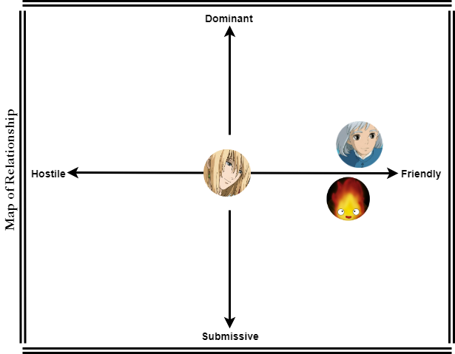

**Figure 7.** *Circumplex of Howl* **Figure 8.** *Relationship Map of Howl*

## The King Mario di Marcello

### **https://lh5.googleusercontent.com/eX4Oyzcag488RHlEh58l1b7CvLF6URoSPZWQeuLmo36gKUoZmrU5xbrotU3J1FRiKnMJQOcBHVIRmOzF95CSXfdEmK_3EC-CmM0q1CFWTkDAs5xJGscIBNohQpuKN2YslhHHNmct**Description

He is also called Magnificent Mario. The King of the Forgotten Florence is trying to save his daughter. He is extremely alone on his throne and desperately missing his family. He doesn’t have any superpowers anymore, all he has is his wisdom and his army. Besides these problems, he can stay powerful. Although his face was not handsome it was as full of dignity as to compel respect. Mario was described as rather plain of appearance and of average height, having a broad frame and long legs, shoulder-length wavy gray hairs and green eyes, a squashed nose, short-sighted eyes, and a harsh voice. He created the Forgotten Florence inspired by the real Renaissance city “Florence” before he lost his powers. But now, he seeks the crown for his only daughter.

### Backstory

Mario considered the most promising of the five children of Piero and Lucrezia. With his brother Giuliano, he participated in jousting, hawking, hunting, and horse breeding. For these a lot of children, he became the King. He is the ruler of Florence, in his big war against dark magic he lost his wife, and now his daughter became a captive of a dark spirit. He is desperately trying to rescue his daughter and trying to find the magical crown which can save his daughter.

### metin, harita içeren bir resim Çok yüksek güvenilirlikle oluşturulmuş açıklamaCircumplex and Relationship Map

**fotoğraf içeren bir resim

Yüksek güvenilirlikle oluşturulmuş açıklama**

**Figure 9.** *Circumplex of Mario di Marcello* **Figure 10.** *Relationship Map of the King*

## Girolamo Riario-The Enemy

### kıyafet içeren bir resim Çok yüksek güvenilirlikle oluşturulmuş açıklamaDescription

Girolamo Riario is the Lord of Imola and Forlì, and a member of the Templar Order. He is the master knight of the dark knights. He is just trying to find the source of dark magic that some people are cursed and looking for. He is really an egoistic man but in addition to that, his soldiers listen to him every time. He is a senior knight also he is strong and master on using the two-handed sword. The most important characteristic of this man is that he is never giving up. He wants the crown and become a more powerful man. Apart from that, he is a father. He is tall and slim. He has dark short hairs and brown eyes. Moreover, he has muscled body **[6]**.

### Backstory

Riario secured his power early in life using his connections to the church. He was married to Caterina Sforza, daughter of Galeazzo Maria Sforza, the Duke of Milan. The couple resided in Rome during Sixtus' pontificate, where Riario gained a reputation for being one of the most ruthless nobles at court. After that, Riario secured the titles of Lord of Imola and Forlì.Girolamo is with the king since he is a little boy, his extreme hunger for power brought him success and he became the head of the king’s knights. He admires dark magic, he believes that he can become superior with dark magic. During events, Riario became a prominent enemy of Mario di Magnifico, leader of the Forgotten Florence, and seek for the magical crown to have more power **[6]**.

### metin, harita içeren bir resim Çok yüksek güvenilirlikle oluşturulmuş açıklamaCircumplex and Relationship Map

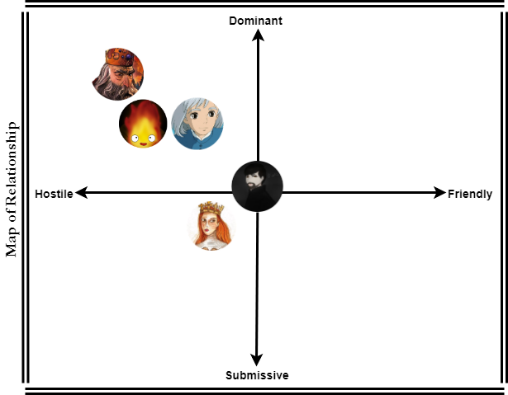

**Figure 11.** *Circumplex of Girolamo* **Figure 12.** *Relationship Map of Girolamo*

## Zeppy – The Evil Twin

### Description

**iç mekan, duvar, tablo, yer içeren bir resim

Çok yüksek güvenilirlikle oluşturulmuş açıklama**The ghost is the twin of Calcifer. No-one can see him except Calcifer. He is a snow demon which can freeze everything. Also, it can fly. It is usually getting bored so want to have fun. Also, it is understanding of fun is making trouble to someone, especially to Calcifer. Because of this, our character “Zeppy” suddenly appears in the tale of our main characters. For example; it turns the wheel while laughing at Calcifer in a mad way and starts our characters adventure. On the contrary, he helped Calcifer and Sophie, when they had in terrible.

### Backstory

Zeppy is the lost sibling (twin) of Calcifer. It borns from the void. It is annoying, mad, and arrogant and the most important thing about it is a big trouble-maker. When Calcifer fell in Howl’s hand before he could fall to earth and disappear it, Zeppy lost his sibling and he could not find him anymore. One day, he saw the Moving Castle and he could not understand how it can move without any magic. Suddenly, he thought that maybe Calcifer moves that castle and check its inside. After that, he saw Calcifer on the woods. He was angry at him. Because of this, he turned something on the door to change their places. However, he used his power and the sector stopped a place where is created by an old magician. It was a magical land, the Forgotten Florence.

### Circumplex and Relationship Map

**nesne içeren bir resim

Yüksek güvenilirlikle oluşturulmuş açıklama**

**Figure 13.** *Circumplex of Zeppy* **Figure 14.** *Relationship Map of Zeppy*

## The Princess Veronica

### Description

**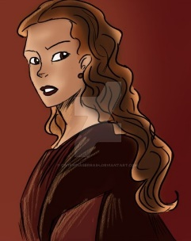**

Veronica is the daughter of the king and her body is possessed by a bad spirit, this spirit uses her body to make her dad (The King) suffer. King needs the magical crown to be able to rescue his daughter’s body from the spirit. She is a very beautiful young woman. All the dukes and princes admire her. They ache to marry her. She has long orange hairs and dark green eyes. She is neither tall nor short. She is clever and charming.

### Backstory

She is an Italian noblewoman. After her father’s relentless war against dark magic, her body is possessed by a spirit. Before this extremely sad situation, she was living happily with her father and mother. Before she cursed, he was about to marry with a rich French Prince. When she lost her spirit, he gave up from marrying. In this way, the King promised that when her daughter woke up, she will not marry with this man.

### harita, metin içeren bir resim Çok yüksek güvenilirlikle oluşturulmuş açıklamaCircumplex and Relationship Map

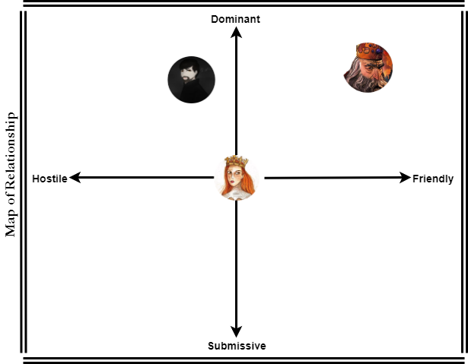

**Figure 15.** *Circumplex of Veronica* **Figure 16.** *Relationship Map of the Princess*

## Interpersonal Circumplex

cihaz içeren bir resim

Yüksek güvenilirlikle oluşturulmuş açıklama

**Figure 17.** *Interpersonal Circumplex of All Characters*

## Relationship Table

|  |  |  |  |  |  |  |  |
| --- | --- | --- | --- | --- | --- | --- | --- |
|  | Sophie | Calcifer | Howl | King Mario | Girolamo | Zeppy | Veronica |
| Sophie |  | **friend** | **love** | **know** | **enemy** | **-** | **know** |
| Calcifer | **friend** |  | **friend** | **know** | **enemy** | **brother** | **know** |
| Howl | **love** | **friend** |  | **-** | **-** | **-** | **-** |
| King Mario | **know** | **know** | **-** |  | **enemy** | **-** | **father** |
| Girolamo | **enemy** | **enemy** | **-** | **enemy** |  | **-** | **old friend** |
| Zeppy | **-** | **brother** | **-** | **-** | **-** |  | **-** |
| Veronica | **-** | **-** | **-** | **daughter** | **old friend** | **-** |  |

**Table 2.** *Relationship Table*

# Story

## Complete Story of the Level

Sophie, Calcifer and Howl live happily together in the moving castle. Sophie has realized to be a powerful witch, yet she is still inexperienced and needs training to master her skills. One day they woke up and they did not see the Howl. But they had no idea about where he went or why did he go. They tried to find him or communicate with him. Sadly, they could not. Howl has dısappeared and never came back. After that, they learned that Howl is kidnapped by an Italian magician who nobody knows him.

Sophie and Calcifer were sitting in Howl’s Castle. They were thinking that everything has been improved and good days were close enough. While they are in these positive thoughts, suddenly Calcifer has been discomforted as he has been feeling that something was walking around the castle. All of a sudden, he heard the laugh of his traitor brother, Zeppy.

Four colored Wheel started to rotate automatically, and a new colored sector has appeared on the magic door. The door of the castle opened spontaneously with the huge wind effect. All the furniture started to fly. Sophie and Calcifer could not hold themselves constant at their places. They could not resist the storm despite all the efforts. Eventually, they found themselves at the middle of the storm, in Florence.

When they woke up, they found themselves among elite people, glamorous and cozy chapels, and flawless architectures. They didn't know why they were here and how they are going to go back. However, as Howl is missing for days there was a possibility that maybe he can be here. They started to discover neighborhoods to know where they are, and what the reason behind being there is. Everyone was staring at them (especially Calcifer). Kids were running away and screaming because of the Calcifer. Also, Calcifer frightened about it and don’t know what to do. They stopped in the first hatter they saw which was in Via de Tortellini. By emphasizing they are a newcomer, they started to ask some questions to the hatter. After he learned that Sophie used to be hatter also, he asked her if there is a possibility that she can work with him, as his assistant is not going to be able to work for a while. He was gazing at Calcifer while making the offer. Although he did not say it out loud, he felt that unordinary events are going to take place soon in Forgotten Florence.

This matter became quickly widespread in the city. No doubt, the king’s family were already aware of the matter as well. They seemed like they were busy with their newly established bank, but King Mario had a bigger trouble. Her daughter, Veronica, was physically beside him, but her soul was taken by evil forces. There was a solution, but she was not strong enough. However, when he heard that a girl name Sophie arrived in the city and she brought a demon with herself, he got his hopes up. Mario could not afford to keep at his castle whitout using their power. It was about his daughter this time. He immediately summoned Sophie and her companions into his castle.

When Sophie and Calcifer arrived, they denied they had an extraordinary power. However, with an offer from the King, everything changed. When the king heard that Sophie and Calcifer had come to find the wizard named Howl, he said that if they could help him to find the object needed for his daughter, he could learn the location of Howl. By the way, the King lost all his power because of creating the Forgotten Florence. Because of that, he needs the help of Sophie and Calcifer. Though Sophie just started to use her power, she accepted the deal by trusting Calcifer.

The object that they are going to look for was a crown, the “Crown of Beauty”. It has colorful stones with different size, and it was gifted to Veronica one year ago. She would be able to free her soul from evil forces and return to life by using this crown. Because when she captured by the evil, she weared this crown. After that, her soul went with the evil, and the crown disappeared magically. For that reason, the King was thinking that if Veronica can wear the crown again, she will have her soul. Because of this reason, King offered an accord. While they were looking for the crown, the King would do what he could for finding Howl, and then give the location of Howl to Sophie and Calcifer. However, there was a big problem. The crown could be anywhere in Forgotten Florence. Moreover, that was not the only problem. Mario di Magnifico’s enemy, Girolamo also wanted to find it. Girolamo wanted the crown for himself because he was thinking that the crown was going to empower him. King Mario’s family were aware of the matter and they were also aware that he couldn’t yet found it. That is why Sophie and Calcifer duty was going to be hard. They found themselves in front of Chapel di Amore without knowing where to start. This place was outside the city walls. When they were thinking about what to do, Girolamo had learned everything. As Girolamo wants to find the crown more than anything, he planned some evils plans to stop Sophie and Calcifer on their journey.

Sophie and Calcifer wasted a lot of time in Chapel di Amore. While passing through Chiesa Fiorentino, the came across with Girolamo. They tried to prevent Girolamo by putting their power together. In this period Sophie’s soul got hurt. When Calcifer saw the condition of his closest friend, he did his best and defeated Girolamo. After that, he shared his power with Sophie and they moved forward Galleria di Angelo. For some period, Girolamo couldn't block their way, but even though he was far from them. He continued to make obstacles for them. Supernatural beings surrounded Sophie and Calcifer in Galleria di Angelo.

Sophie was so desperate. She started to think nothing is going to recover and they are not going to find Howl. While she was in misery, she heard Calcifer’s voice at a distance. However, the one who was talking was not Calcifer, in fact, it was his twin brother Zeppy. At that moment, everything became clear for Calcifer. The one who has turned the wheel was his sibling. But why was he here right now? Would he help them? While Calcifer was thinking about those things, Zeppy moved and destroyed all obstacles in front of him with his special powers. While he was thinking of getting out, Zeppy moved in a different direction. Calcifer wanted to thank him, so he went after him. Zeppy was in front of a well. He jumped in and came back a little later. He had a crown with a lot of valuable stones. Brothers glanced to each other for a moment. Zeppy told them that they should take the crown and go away because Girolamo could block them again, and he gave the crown to the Sophie.

Sophie came back to the Palazzo di Nuovo with Calcifer. She handed the crown to Mario. Mario didn't want to give the letter before putting on the crown on his daughter’s head. The king ran into Veronica's room. As soon as the crown was put on her head, she came back to life. She started to breathe, she survived. After that, Mario give the letter to them. He found where Howl is; however, he said that they could not save him. This was not a problem for Sophie and Calcifer. Nobody could spoil their mood now. Regardless of her being a witch, she was not killed and the idea of her being together with Howl made her excited. They opened the envelope and took the paper inside it. Howl is at “Fire Island” which is an island near the Forgotten Florence. Afterwards, they arrived in the Moving Castle with Howl’s impressive magical power. It was faster than everything. But this adventure was not enough for them. They started to prepare for a new legacy. Sophie and Calcifer even happier than before…

## Dialogues on the Level

**In Galleria di Angelo:**

**Sophie:** Calcifer, my friend, I do not want to give up, but I do not have any strength.

**Calcifer:** Stay with me Sophie, I am more powerful with you. You feel like me that there is no place like our castle, with Howl. Thus, we must find Howl. Prepare to win.

**Sophie:** I am always with you Calcifer, do not worry.

**Calcifer:** Support me with your power.

**Sophie:** I am not a powerful witch Calcifer…

**Calcifer:** I do not want to survive Sophie. I just want to live with you and Howl.

**Sophie:** I know that you make me want to be a better witch. Let’s fight my little friend.

>> Sophie stands up and walk over to the obstacles...

**In Palazzo di Nuovo, after finding the magical crown:**

**King:** I very appreciate meeting with you guys.

**Calcifer:** Also, us…

**King:** Now, my daughter woke up, and told me “father” after one month. Love means never giving up.

**Sophie:** I understand you sir (sigh)…

**King:** You love Howl very much, Sophie. I can see this in your eyes.

**Sophie:** Could you find his place?

**King:** Yes, I could. I will give you the rotation. Before that, I want to say something to you… When you realize you want to spend the rest of your life with a man, you want the rest of your life to start as soon as possible.

**Calcifer:** (fill with tears)

**Sophie:** We will rescue him as soon as possible. Howl is everything of me.

**King:** (give the route) – Now, you are free. I wish I knew how I can help you. But, this is what I can. You are alone in this new adventure, goodbye…

>> Sophie and Calcifer left the room…

# Detailed Level Description

## Level Flowchart

harita, metin içeren bir resim

Çok yüksek güvenilirlikle oluşturulmuş açıklama

**Figure 18.** *Basic Flowchart of the Story*

## Documents Level

* **Ideas:** For each area, we assigned some basic ideas or requirements, so that we have a short list that tells us the structure of our level. We will show that int he content segment.

Areas are connected to each other (link them) in a physical place. It gives us a foundation for understanding the basic flow of my new level at a glance.

* **Size:** It will be a single player game. Therefore, we will design multiple focal points using architectural structures, landscape elements, lighting that help the player to travel from one location point to another.
* **Progression:** For our level, we decided that the challenges should not be too hard. According to our researches, we realized that there a lot of fun of “Howl’s Moving Castle” who has under 18 (ages). So that, that level will be easy to play for our player.
* **Amount of content per area:** For our level, the areas’ description is below:

**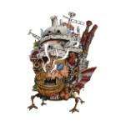**

**Howl’s Moving Castle:** Start of the level; safe—no enemies. However, Zeppy looks like an enemy in this area, in contrast, he is not.

1

****

**The Hatter:** The path behind us closes off somehow to the Moving Castle.

2

****

**Palazzo di Nuovo:** When you came a second time here, you can go to directly the Moving Castle to go to Howl.

3

**\\unicloudidattica.local\share\Home\simge.haksal\Downloads\Untitled Diagram (3).png**

**Chapel di Amore:** The closest path to the Palazzo di Vecchio. It is a good idea to seek the crown here.

4

****

**Chiesa Fiorentino:** One encounter with Girolamo, the enemy.

5

****

**Galleria di Angelo:** A vertical fight against enemies; obstacles which are stones. We need a one-way exit back to the palace.

6

*This is the simplemap version of the World Diagram. Our map is surrounded by different types*

*of trees. Every rectangle represents another place which you can find the detailed*

*information in the area description part.*

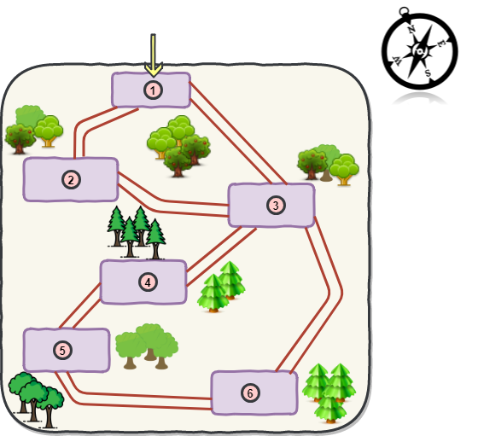

**Figure 19.** *Simple Level Diagram*

The first area is of course Howl’s Moving Castle. This is the very first area of the level, it starts with Sophie and Calcifer, and Howl is just kidnapped outside the castle by the italian magician. The castle is safe, there is no enemies insidethere. However, Zeppt enters to the home by using his magical power and everything is change. He cannot damage anyone but makes something bad which will convert into good thing. Sophie and Calcifer are talking near the table. This area is 9m wide and 20m long.



Before something happened, the castle was near the river between flowers so that the sound is pipe. Also, you can hear the river at the background. Bird communicates each other, and Sophie is talking with her soft voice.

## Detailed Area Description

### Howl’s Moving Castle

#### Inside the Castle

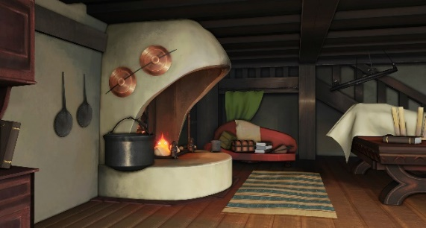

This is the living room of the Howl’s Moving Castle. This room is a place where visitors only stay. Also, Calcifer appears continuously in this room before this new adventure. In this way, he moves the castle. Furthermore, he supplies the warm water for the castle, and Sophie can cook by using Calcifer’s fire.

**Figure 20.** *Living Room of the Moving Castle*

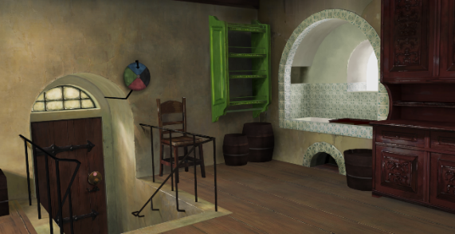

This is the enterance of the Moving Castle. It is linked with the living room. You can clearly see that there is a small circlenear the doorknob, and where the door leads to when opened depends on what color the circle is turned to. This allows the residents to jump many many miles nearly instantly.

**Figure 21.** *Entrance of the Moving Castle*

|  |  |  |  |
| --- | --- | --- | --- |
| In the Book | | In the Movie | |
| *Before the Move* | *After the Move* | *Before the Move* | *After the Move* |
| Green:  The Chipping Valley | Purple:  The Waste Garden | Green: The Waste | Green: The Waste |
| Red: Kingsbury | Orange: Chipping Manor | Red: Kingsbury | Pink: Howl’s Garden |
| Blue: Porthaven | Yellow: | Blue: Porthaven | Yellow: Market Chipping |
| Black: Wales | Black: Wales | Black: Howl’s Portal | Black: Howl’s Portal |



**Figure 22.** *PortalDial* **Table 3.** *Relationship Table* **[7]**

In our level, the hook is turned by the evil twin Zeppy randomly. However, every places changed with this turning. Then, the hook stopped on the black sector, and the door is opend to the Forgotten Florence. Sophie and Calcifes are forced to exit the Moving Castle. They thought that this is the destiny to find Howl’s new place, and the new adventure starts…

#### Outside the Castle

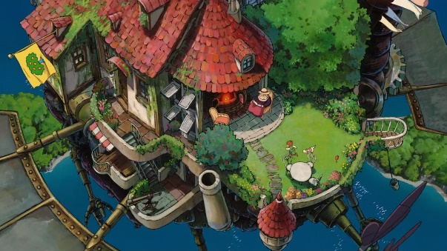While the castle is moving with the power of Calcifer, Sophie can see the outside by sitting at the balcony. Besides the balcony, there are more important things which are three “doors”. However, two of these doors cannot be approached at all, as though there was an invisible barrier blocking the way. Only the third door can be reached, which although is the back door of the castle, is the front door of the house within **[2]**.

**Figure 23.** *The Balcony of the Moving Castle*

### The Hatter

**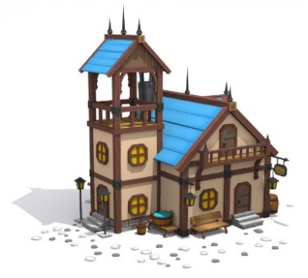**

It is not a special hatter. It is the nearest hater to the Moving Castle. The owner of the hatter is a woman who likes gossiping. After Sophie and Calcifer quited from the hatter, she told everybody that there are two new guests ın the Forgotten Florence. One of hem is a small demon and the other is a wizard. After that, events occur, and the King invited the new guests.

**Figure 24.** *The Hatter*

### Palazzo di Nuovo

iç mekan, tablo içeren bir resim

Yüksek güvenilirlikle oluşturulmuş açıklamaPalazzo di Nuovo is the town hall of the Forgotten Florence. The walls in the rooms have elements that are filled with different concepts. One of them represents Saturn, the other is Venus. After the planet’s names, the rooms continue with flower’s name, and it continues like that. The King lives in “Mars” room, and Veronica sleeps in “Rose” room.

**Figure 25.** *Palazzo di Nuovo*

### Chapel di Amore

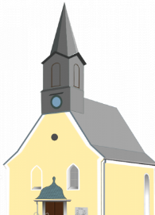

It is created by a famous architect. The chapel is located within church and gallery. However, it is not used as a chapel. It was devoted to lovers. If someone breaks up his/her partner, he/she comes there, and prays to ome together again. Sophie and Calcifer seeks the crown there since it is an emotional place.

**Figure 26.** *Chapel di Amore*

### Chiesa Fiorentino



Chiesa Fiorentino looks like amazing wit its white color. Because of the appearance Sophie and Calcifer wanted to enter the church. There is something like mysterious, and it attracted people with its beauty. It has yellow windows without motifs.

**Figure 27.** *Chiesa Fiorentino*

### Ä°lgili resimGalleria di Angelo

Galleria di Angelo is the most famous and the biggest museum of the Forgotten Florence. There are a lot of valuable artistic pictures in the highest floor of that museum. Sophie and Calcifer are blocked by obstacles which are stones. These come for killing them. However, they got over from the stones, and found the crown with the help of Zeppy at basement.

**Figure 28.** *Galleria di Angelo*

## Measurements

### Measurement for Characters

**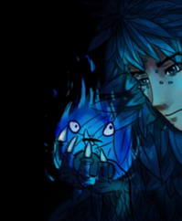**  küçük resim içeren bir resim

Yüksek güvenilirlikle oluşturulmuş açıklama

**Sophie Height = 1.65m Calcifer Height = 0.30m Zeppy Height = 0.30m**

**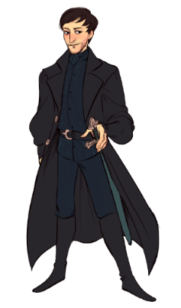**

**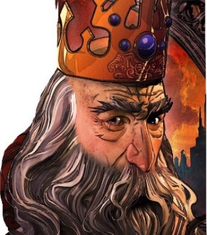**

**Mario di Marcello = 1.70m Girolamo Height = 1.80m**

They are characters who actively take rolls in that level, so that the information of height is needed.

### Measurement of the Obstacles

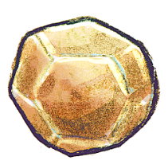 

**The Bright Rock Height = 0.70m The Wight Rock Height = 0.40m**

### Measurement of the Mission Object

 

**The Magical Crown Height = 0.20m The Letter Height = 0.10m**

## Character Statistics

A statistic (stat), is a number describing an aspect of a game entity. A game entity might be a monster, character, weapon or spell. Stats define game entities in the world. For the following section, we will only show the characters who have magical power. For now, let’s start with the characters by using these stats **[8]**:

**Strength** - describes the character's physical strength. Defines the number of damage attacks inflict.

**Velocity** - represents how fast the character moves. Determines the frequency of attacks and a chance to avoid incoming attacks.

**Dexterity** - controls attack and movement speed and accuracy, as well as avoiding an opponent's attack.

**Intelligence** - represents how clever the character is. Determines the power of spells and the ability to maintain magic attacks.

**Wisdom** - frequently controls a character's ability to pick certain spells, communicate to mystical entities, or recognize other characters' motives or feelings. A measure of the character's mental resistance against pain, fear etc., when falling victim to mind-altering magic, torture, or insanity.

**Charisma** - a measure of a character's social skills, and sometimes their physical appearance.

**Health Points or HP** - represents the amount of damage a character can take before dying or being knocked out.

**Magic Points or MP** - represents the amount of magical power a character has. The higher the power, the more spells can be cast.

**Attack Type** - can be a physical attack, magical, elemental, or a combination.

**Attack Power** - how much damage can this weapon inflict?

**Defense Power** - how much damage can this weapon block?

**Attack Rate** - how quickly can the weapon be used to attack? Is it a small knife, gun or giant hammer?

**Armor Class or AC** - is a derived statistic that shows how difficult it is to land a successful blow on a character with an attack.

**Base Attack Bonus or BAB** - is a to-hit modifier. The attack bonus on your status screen is your to-hit bonus. It is a factor of the attack bonus of the weapon, your dexterity, and your level. This number determines your chance to overcome the enemy's AC and do any damage at all.

### Sophie Hatter’s Stat

|  |  |  |
| --- | --- | --- |
| *Sophie Hatter* | Wizard lv.2 | |
| *Strenght* | 8 | -2 |
| *Constitution* | 6 | -1 |
| *Dexterity* | 12 | +2 |
| *Intelligence* | 18 | +3 |
| *Wisdom* | 10 | 0 |
| *Charisma* | 10 | 0 |
| *TS (Temper)* | 2 | 2 (CON) |
| *TS (Reflexes)* | 2 | 3 (DEX) |
| *TS (Will)* | 6 | 0 (WIS) |
| *Health Point* | 40 | D10+2(CON) |
| *Magic Points* | 10 | |
| *AC* | 10 | Armour(2) |
| *BAB* | +1 | |
| *Attack Type* | Magical | |
| *Attack Power* | +2 | |
| *Defense Power* | +1 | |
| *Velocity* | 6 m | |
| *Size* | Medium | |



**Table 4.** *Statistic of Sophie*

### Calcifer’s Stat

|  |  |  |
| --- | --- | --- |
| *Calcifer* | Demon lv.10 | |
| *Strenght* | 18 | +1 |
| *Constitution* | 6 | +3 |
| *Dexterity* | 16 | +2 |
| *Intelligence* | 10 | -1 |
| *Wisdom* | 10 | 0 |
| *Charisma* | 10 | 0 |
| *TS (Temper)* | 1 | 1 (CON) |
| *TS (Reflexes)* | 2 | 3 (DEX) |
| *TS (Will)* | 6 | 0 (WIS) |
| *Health Point* | 58 | D10+2(CON) |
| *Magic Points* | 18 | |
| *AC* | 15 | Armour(2) |
| *BAB* | +6 | |
| *Attack Type* | Magical | |
| *Attack Power* | +4 | |
| *Defense Power* | +4 | |
| *Velocity* | 9 m | |
| *Size* | Small | |

**Table 5.** *Statistic of Calcifer*

### Girolamo – The Enemy

|  |  |  |  |
| --- | --- | --- | --- |
| *Girolamo Riario* | Wizard lv.6 | | |
| *Strenght* | 12 | | +2 |
| *Constitution* | 5 | | -1 |
| *Dexterity* | 14 | | +2 |
| *Intelligence* | 15 | | +1 |
| *Wisdom* | 10 | | 0 |
| *Charisma* | 10 | | 0 |
| *TS (Temper)* | 2 | | 2 (CON) |
| *TS (Reflexes)* | 2 | | 3 (DEX) |
| *TS (Will)* | 6 | | 0 (WIS) |
| *Health Point* | 48 | | D10+2(CON) |
| *Magic Points* | 12 | | |
| *AC* | 15 | Armour(1) | |
| *BAB* | +1 | | |
| *Attack Type* | Magical | | |
| *Attack Power* | +2 | | |
| *Defense Power* | +2 | | |
| *Velocity* | 6 m | | |
| *Size* | Medium | | |

**Table 6.** *Statistic of Girolamo*

### Zeppy

|  |  |  |
| --- | --- | --- |
| *Zeppy* | Demon lv.10 | |
| *Strenght* | 18 | +1 |
| *Constitution* | 6 | +3 |
| *Dexterity* | 16 | +2 |
| *Intelligence* | 10 | -1 |
| *Wisdom* | 10 | 0 |
| *Charisma* | 10 | 0 |
| *TS (Temper)* | 1 | 1 (CON) |
| *TS (Reflexes)* | 2 | 3 (DEX) |
| *TS (Will)* | 6 | 0 (WIS) |
| *Health Point* | 58 | D10+2(CON) |
| *Magic Points* | 18 | |
| *AC* | 15 | Armour(2) |
| *BAB* | +6 | |
| *Attack Type* | Magical | |
| *Attack Power* | +4 | |
| *Defense Power* | +4 | |
| *Velocity* | 9 m | |
| *Size* | Small | |

**Table 7.** *Statistic of Zeppy*

# Data Management

## Paths and Project Structure

The project directory is the one that contain the “git” folder: <https://github.com/simgehaksal/TheForgottenFlorence.git>

You can see the project structure below:

The Forgotten Florence

High Concept

Periodic Table of Storytelling

Resources

Characters

Name

Story

Reference Picture

Sounds

Objects

Name

Description

Reference Picture

Sounds

Levels

Flowchart

Maps

City Name

Zone

Description

Detailed Map

Reference Picture

Sounds

Rooms

Description

Reference Image

Sounds

Logos

Prototypes

Unity Project

## Naming Convention

We will use camel and pascal case for naming conventions. In Camel Case, each word is capitalized, except possibly the first word like lowerCamelCase. The Camel Casing convention used only for parameter names. Apart from camel case, there is also pascal case. The Pascal Casing convention, used for all identifiers except parameter names, capitalizes the first character of each word like HtmlTag. A special case is made for two-letter acronyms in which both letters are capitalized like IOStream.

|  |  |  |
| --- | --- | --- |
| Identifier | Casing | Example |
| Namespace | Pascal | namespace System.Security { ... } |
| Type | Pascal | public class StreamReader { ... } |
| Interface | Pascal | public interface IEnumerable { ... } |
| Method | Pascal | public class Object {  public virtual string ToString();  } |
| Property | Pascal | public class String {  public int Length { get; }  } |
| Event | Pascal | public class Process {  public event EventHandler Exited;  } |
| Field | Pascal | public class MessageQueue {  public static readonly TimeSpan  InfiniteTimeout;  }  public struct UInt32 {  public const Min = 0;  } |
| Enum value | Pascal | public enum FileMode {  Append, ... } |
| Parameter | Camel | public class Convert {  public static int ToInt32(string value);  } |

**Table 8.** The Capitalization Rules

This level will implement on Unity Game Engine by using C# programming language. So that, the practical project will be written by using camel and pascal casing. In the Pascal Casing, the class names and method names will be looked like that:

public class ClientActivity {

public void ClearStatistics() { //... }

public void CalculateStatistics() { //... }

}

In the Camel Casing, the method arguments and local variables will be looked like that:

public class UserLog {

public void Add(LogEvent logEvent) {

int itemCount = logEvent.Items.Count;

// ...

}

}

|  |  |
| --- | --- |
| Group | Conventions |
| Logo | LG\_[company name].ext |
| Cover | COV\_[project name].ext |
| Periodic Table | PTS\_[part/character name].ext |
| World Diagram | WD\_[ project name].ext |
| Character Pictures | PIC\_[character name].ext |
| International Circumplex | IPC\_[character name].ext |
| Relationship Map | MAP\_[character name].ext |
| Area Pictures | AC\_[area name].ext |
| Flowchart | FC\_[level name].ext |

**Table 9.** Naming Convention

# Reference Lists

1. Harris, J., “The PeriodicTable of Storytelling”. Retrieved from <http://jamesharris.design/periodic/>
2. “Howl’s Moving Castle (film)”. Retrieved from <https://en.wikipedia.org/wiki/Howl%27s_Moving_Castle_(film)>
3. “Howl’s Moving Castle”. Retrieved from <https://sites.google.com/site/howelljenkinscastle/characters>
4. Fandom (n.d.), “Califer”. Retrieved from <https://studio-ghibli.fandom.com/wiki/Calcifer>
5. Fandom (n.d.), “Howl’s Moving Castle Wiki”. Retrieved from <http://howlscastle.wikia.com/wiki/Howl_Jenkins_Pendragon>
6. Fandom (n.d.), “Girolamo Riario”. Retrieved from <http://assassinscreed.wikia.com/wiki/Girolamo_Riario>
7. Fandom (n.d.), “Howl’s Moving Castle”. Retrieved from <http://howlscastle.wikia.com/wiki/Howl%27s_Castle>
8. “How to Make an RPG:Stats” Retrieved from <http://howtomakeanrpg.com/a/how-to-make-an-rpg-stats.html>

***These numbers represent the references, you can see these somewhere in the report in that format [number]; this is APA Format to avoid plagiarism.***